Fresh Water Debate
Over the past few days we have discussed the impacts on population sizes due to limiting factors. We collected data from our school wide Ecosystem Game in which the limiting factor of unusual weather, specifically a drought negatively impacted animal populations. This even caused the limiting factor of competition to be exacerbated or intensified. However, now we will look at a real world example of how this limiting factor of unusual weather can affect not only animals in the wild but human populations as well.
Directions: This will be a multiple day activity that will be in three separate steps. You and your classmates will be divided into two groups, Californians from San Jose or Illinoisans from Chicago, and your information will be based on where you are from. The first step will be to thoroughly read and annotate your assigned background information included in this document and complete the guided questions (A-D). Next, you and a partner from your “state” will pair with another partner group from the “other state” and teach them about your concerns based on the guided questions on THEIR PAPER (E-G). Lastly, we will conclude with an in-class debate to see which “state” can provide the best argument and counterargument to deal with the limiting factor of unusual weather.
Location: San Jose, California Issue: Experiencing severe drought

Background Information:
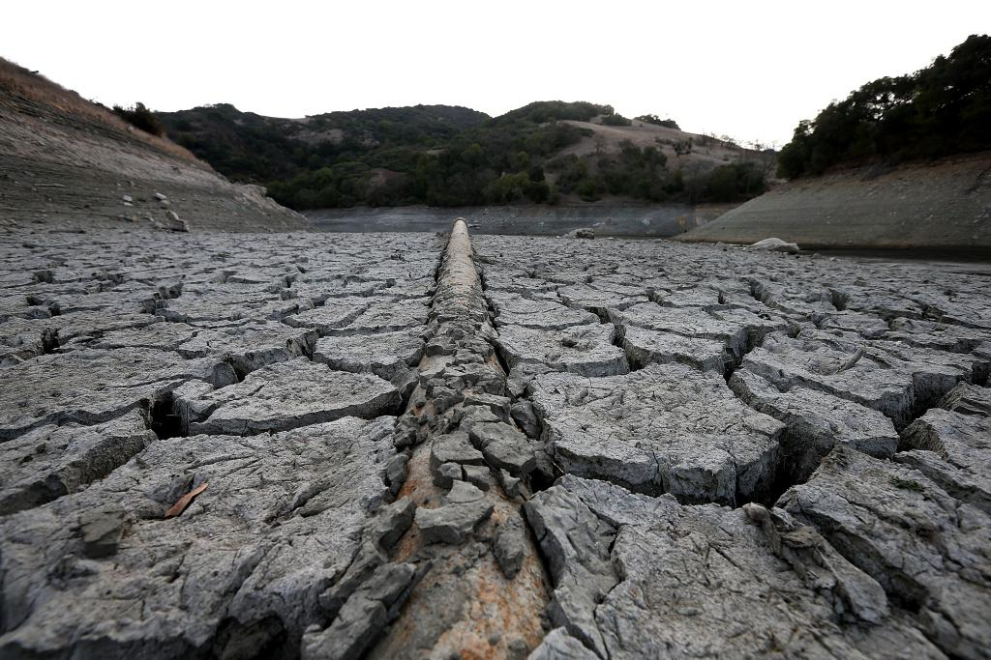

A pipe emerges from dried and cracked earth that used to be the bottom of the Almaden Reservoir on January 28, 2014 in San Jose, California. Now in its third straight year of drought conditions, California is experiencing its driest year on record, dating back 119 years. The reservoirs throughout the state have low water levels. California Governor Jerry Brown officially declared a drought emergency to speed up assistance to local governments, update water transfers and potentially ease environmental protection requirements for the release of dams, regulating water flow. In addition, they have a mandated 25 percent cut in urban water use throughout the cities.

Impacts: Drought affects all parts of our environment and our communities. The many different drought impacts are often grouped as “economic,” “social” and “environmental” impacts. All of these impacts must be considered in planning for and responding to drought conditions
Economic impacts are those impacts of drought that cost people (or businesses) money. Here are just a few different examples of economic impacts:

1. Farmers & ranchers may lose money, due to destroyed crops and spending more money on feed and water for their animals. This also would be major concerns for environmental protection agencies.
2. Local Businesses that depend on farming, like companies that make tractors and food, may lose money when drought damages crops or livestock.
3. Other businesses like power companies that normally rely on hydroelectric power (electricity that's created from the energy of running water) may have to spend more money on other fuel sources if drought dries up too much of the water supply and/or have to spend money on new or additional water supplies
4. Businesses that rely on water transportation may have difficulty navigating streams, rivers, and canals because of low water levels, which would also affect businesses that depend on water transportation for receiving or sending goods and materials. This also would be major concerns for environmental protection agencies.
5. Homeowners/consumers would also have to pay more for their services that rely on water, like electricity and food.

Social impacts of drought are ways that drought affects people’s health and safety. Social impacts include public safety, health, conflicts between people when there isn't enough water to go around, and changes in lifestyle. Because social impacts society on a grand scale, these issues become big concerns for homeowners and politicians. Examples of social impacts include:

1. Anxiety or depression about economic losses caused by drought
2. Health problems related to low water flows, poor water quality and related to dust
3. Loss of human life and animal life
4. Threat to public safety from an increased number of forest and range fires
5. Reduced incomes
6. People may have to move from farms into cities, or from one city to another. This too becomes an economic issue
7. Fewer recreational activities

Environmental Impacts of droughts have far reaching impacts on plants, animal, climate, soil, and rocks. Some biotic and abiotic factors recover when the droughts are over but others never recover again. These impacts are huge concerns for those in different environmental protection agencies around the globe. Listed below are several environmental impacts that can occur:

- Lowered soil quality, which leads to less organic activity, more wind erosion, and declines in the population of soil insects/organisms.
- Habitat destruction occurs within bodies of water like lakes, creeks, ponds, and lagoons. This causes the death of many water animals.
- Desertification (when land used for vegetation becomes infertile) intensifies with more occurrences of droughts.
- Animals have to migrate long distances in search of water which makes them more vulnerable to new threats.
Proposed Solution:
When Gov. Jerry Brown said on April 1 that “this historic drought demands unprecedented action”, other governors surely nodded. The action he believes is best is to transfer fresh water from other locations and bring it to California. In addition, New Mexico Gov. Bill Richardson suggested that Great Lakes water be piped to the rapidly growing and increasingly dry Southwest: “States like Wisconsin are awash in water.” Because the Great Lakes have what others believe is an abundance of fresh water the officials in California argue that they should quote “share the wealth”.

Part 1 Guided Questions: Use the information you just read about to answer the following questions.
A: Approximately how long has it been since California’s driest season? ___________________
B: Predict why officials would require urban residents to cut back water use by 25%. ____________________________________________________________________________________________________________________________________________________________
C: What are the three types of impacts of droughts?
_______________ _______________ _______________
D: If you were on a committee in support for Governor Brown, list two pieces of evidence you would cite for each economic impacts, social impacts, and environmental impacts (from above) to strengthen the argument to transfer water from the Great Lakes.
- ________________________________________________________________________________________________________________________________________________
- ________________________________________________________________________________________________________________________________________________
- ________________________________________________________________________________________________________________________________________________
- ________________________________________________________________________________________________________________________________________________
- ________________________________________________________________________________________________________________________________________________
- ________________________________________________________________________________________________________________________________________________

*Stop! Bring your paper up to your teacher and get a stamp

Part 2 For part 2 you will be paired with someone who had the article about Chicago. Read them the question and write down their response.
E. What are the five lakes that make up the Great Lakes? What two countries border the Great Lakes?
_______________________________________________________________________________________________________________________________________________________________________________________________________________________________________________________________
F. Lake Michigan is responsible for what major resource for the people in the Chicagoland area?
_____________________________________ _______________________________________

G. The following statements are arguments about being against moving fresh water to California.
Identify if the statement is true or false. If it is false, correct the statement.

- True or False. A government contract has already been put in place to restrict movement of water from the great lake basin area.

- True or False. The movement of the high value resources of water will cause residents and businesses to migrate away from the Great Lake area.

- True or False. The Great lakes water resource could supply every state with water.

*Stop! Bring your paper up to your teacher and get a stamp

Part 3 In order to prepare for the debate you are going to make a poster using both the role you are assigned and the previous information provided. Follow the template given below.
Role Title | Description of Role (according to interest given)
Evidence # 1 related to role  -direct quote | Description of evidence #1 in your own words or picture
Evidence # 2 related to role  -direct quote | Description of evidence #2 in your own words or picture
Evidence # 3 related to role  -direct quote | Description of evidence #3 in your own words or picture

