Fresh Water Debate
Over the past few days we have discussed the impacts on population sizes due to limiting factors. We collected data from our school wide Ecosystem Game in which the limiting factor of unusual weather, specifically a drought negatively impacted animal populations. This even caused the limiting factor of competition to be exacerbated or intensified. However, now we will look at a real world example of how this limiting factor of unusual weather can affect not only animals in the wild but human populations as well.
Directions: This will be a multiple day activity that will be in three separate steps. You and your classmates will be divided into two groups, Californians from San Jose or Illinoisans from Chicago, and your information will be based on where you are from. The first step will be to thoroughly read and annotate your assigned background information included in this document and complete the guided questions (A-D). Next, you and a partner from your “state” will pair with another partner group from the “other state” and teach them about your concerns based on the guided questions on THEIR PAPER (E-G). Lastly, we will conclude with an in-class debate to see which “state” can provide the best argument and counterargument to deal with the limiting factor of unusual weather.
Location: Chicago, Illinois Issue: California wants to take our city’s fresh water
Background Information:

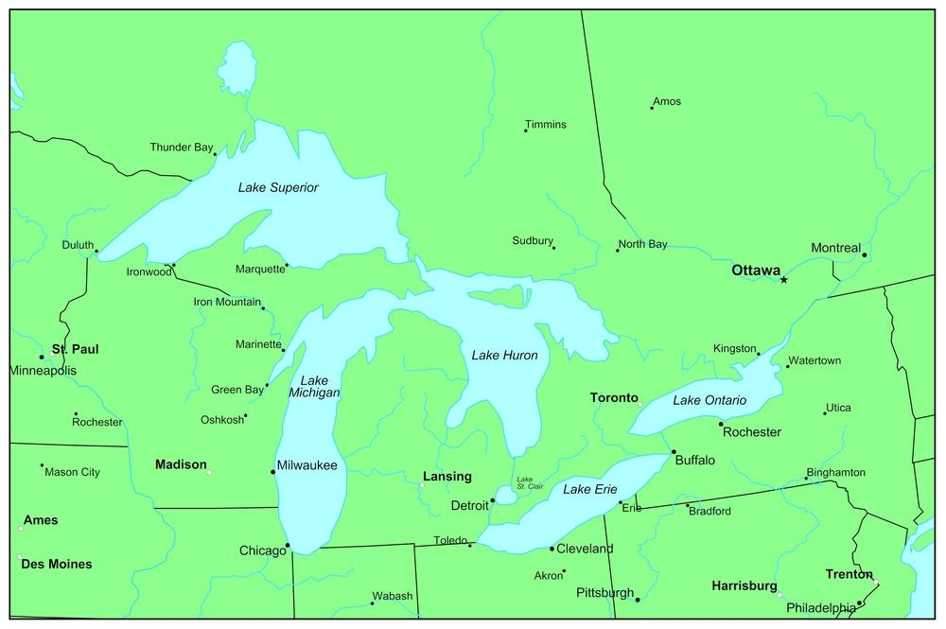
Water is a critical resource that is essential for all forms of life and for a broad range of economic and social activities. The Great Lakes, sometimes referred to as North America's inland sea, are one of the largest freshwater ecosystems in the world. They support about 40 million people and diverse biotic populations (animals included). The Great Lakes — Superior, Huron, Michigan, Ontario and Erie — make up the largest body of freshwater on Earth, it is about 6 quadrillion gallons. The lakes are on the U.S. and Canadian border, touching Ontario in Canada and Michigan, Wisconsin, Minnesota, Illinois, Indiana, Ohio, Pennsylvania, and New York in the United States. About 34 million people in the United States and Canada live in the Great Lakes basin. More than 3,500 species of plants and animals inhabit the Great Lakes basin, including 170-plus species of fish. Today, the Great Lakes are popular recreation spots for boating, fishing and other recreational activities and still serve as an important mode of transportation of goods. Specifically here in Chicago, Lake Michigan, like the other Great Lakes, supplies drinking water to millions of people in bordering areas.

Economic Impact: Economic impacts are those factors that cost or bring homeowners or local businesses money. Because of that fact, it is of big interest to them and politicians. Here are just a few different examples of economic impacts:

- The Great Lakes provide 1.5 million jobs in the U.S, and $62 billion in wages every year, according to a study at the University of Michigan. "Many people don't realize how large an impact the Great Lakes have across many large territories of this region's economy," Jennifer Read, the Sea Grant's assistant director said. "The total number of jobs and the percentage of jobs by industry illustrate just how critical the Great Lakes are to the region. For example, there are more than 525,000 Great Lakes-related jobs.
- The study also said 66 percent of those jobs were in manufacturing, with tourism next at 14 percent. Shipping and agriculture each accounted for 8 percent, while science and engineering, utilities and mining had smaller percentages. The study said ships on the Great Lakes annually carry 163 million tons of cargo, and are more efficient than rail or trucks. This too can become a concern for agriculture specialists

Major Issues with the Idea of Transferring Fresh Water from Lake Michigan:
- The process of taking the water can harm the ecosystem: (this is a major issue for
environmental protection agencies)
-“Human activities beyond water removals and consumption have had impacts on the natural environment of the Great Lakes ecosystem. Land use changes, water pollution, regulation of lake levels, channel work for navigation, construction of dams, other activities, and development of wetlands can affect water levels, destroy habitat. The Great Lakes aquatic ecosystem is made up not only of the lakes themselves, but also of the complex network of tributaries and groundwater on which the lakes depend. Changes to the lakes, the tributaries, or the groundwater can alter the balance of the ecosystem of the region in significant and sometimes unpredictable ways.”
- The process of moving water that far, and that amount, wouldn't make economic
sense.
- “The economics of trucking likely would limit any such transfer. But we don’t doubt that some future technology may make transfers affordable — an adjective defined by the severity of an Emergency.”
- Great Lakes water is locked down politically.
- “The eight states (Illinois included) and two Canadian provinces that border the lakes hope no outsiders can breach the invisible, 5,500-mile wall they’ve erected because in 2008, President George W. Bush signed into law “the Great Lakes-St. Lawrence River Basin Water Resources Compact”. All eight states and Congress approved the compact, with the Canadians applauding. It intended to severely, although not absolutely, block new diversions of water outside the Great Lakes’ vast drainage basin.”
4) If water truly is the new oil, Illinois and its neighbors could see their most valuable
resource lure alien (those new to the area) businesses and citizens to the Midwest.
-“The Chicagoland area contains nearly 10 million people in three states – Illinois,
Wisconsin and Indiana – and is the 22nd largest metropolitan area in the world. The city
area and it’s resources are already highly used over capacity and can barely support
those that currently live here now.”
5) Everyone will constantly want to take it from us and we won’t have any more.
-A 2013 survey by the U.S. Government Accountability Office found 40 states expecting water shortages over the next decade under “average” population shifts, economic growth and weather. Imagine the future need for water in Texas, where the state Water Development Board anticipates population to grow by 80 percent over the next 50 years.
- many of the city’s suburbs draw from the lake sit outside its watershed; rain that falls on them flows to the Gulf of Mexico via the Illinois and Mississippi rivers.
Proposed Solution:
We’ll advocate other protections, too: The wrong time to think about conserving water, or improving its quality, is when supplies of it dwindle. Californians haven’t conserved enough before but clearly they need to start NOW.

Guiding Questions: Part 1
A: About how many people live in the Great Lakes basin? ___________________

B: Identify 3 things the Great Lakes are known for according to the background information.

________________________ _______________________ ________________________

C: Predict why was Jennifer Read’s data about wages cited as an economic impact of the Great Lakes. ______________________________________________________________________________
______________________________________________________________________________

D: If you were on a committee to reject the Governor of California’s request to transfer fresh water from Lake Michigan to his state, list four pieces of evidence you would cite (from above) to strengthen your argument.
- ________________________________________________________________________________________________________________________________________________
- ________________________________________________________________________________________________________________________________________________
- ________________________________________________________________________________________________________________________________________________
- ________________________________________________________________________________________________________________________________________________

Stop! Bring Your paper up to your teacher and get a stamp

Part 2 For part 2 you will be paired with someone who had the article about California. Read them the question and write down their response.
E. What was the physical evidence was visible that the earth top soil dried up due to a drought.
__________________________________________________________________________________________________________________________________________________________________________________________________________________________________________
F. What were 2 of the 3 emergency action plans Governor Brown put in place?
i. ____________________________________________________________________________
ii.____________________________________________________________________________
G. The following are economic and social impacts of the drought identify if they are true or false. Correct the false statements and make them true.
- True or False. Ships and their navigation systems find it easier to navigate streams and rivers because of lower water levels.

- True or False. Hydroelectric power companies (those that create energy from water) spend more money and charge customers more money.
- True or False. People move from cities to farms to find more job opportunities.

Part 3 In order to prepare for the debate you are going to make a poster using both the role you are assigned and the previous information provided. Follow the template given below.
Role Title | Description of Role (according to interest given)
Evidence # 1 related to role  -direct quote | Description of evidence #1 in your own words or picture
Evidence # 2 related to role  -direct quote | Description of evidence #2 in your own words or picture
Evidence # 3 related to role  -direct quote | Description of evidence #3 in your own words or picture

